**Data Analysis**

Data Analysis is an important step in Data Science Project. After analyzing the Data and inspecting each feature meticulously, the Machine Learning model will be fitted. Analysis helps to manipulate the data as per the requirements and increase the overall performance of the Model. It also, helps in Feature Selection which in turn impacts the Accuracy of ML model.

* Analysis helps to gain insights about various features that affects the Target Variable.
* To better understand any data, Data normalization with Visualizations helps.
* Feature Importance in the data helps figuring out the most affecting Feature which can be taken into consideration to improve the accuracy of predicting Target Variable (in this project, predicting the Employee Performance).
* Having good Domain expertise and better Analytical techniques helps to improve the Model efficiency.

Example:

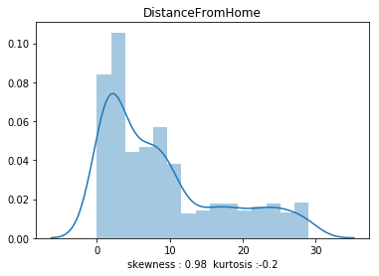

Submitted By: Kiran B Kulkarni